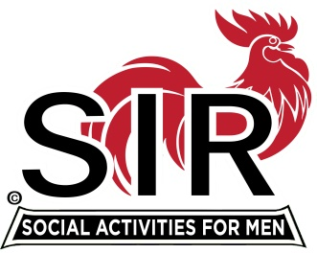
Las Trampas Branch 116
BEC Meeting Agenda
September 16, 2019, 9:30 AM
The Mission of SIR is to enhance the lives of our members through fun activities, events and luncheons – while making friends for life.

09:15 Coffee Available
09:30 Call to order; Secretary confirm a quorum
09:31 Secretary – Fred Schafer – Approval of August 19, 2019 minutes
09:33 Treasurer – Jim Nickels – Report, Missed Luncheon Receipts
09:37 Standing Reports
- Attendance – Jim Flessner – Attendance, Guests and Visitors – Scott Clark guest of Tom O’Brien; John Alonso guest of Dennis Snarr
- Membership – Phil Goff – New Members to be inducted; Paul Russel, sponsor Gary Boswell. Resignation of Essie Naddaf
- Christmas Party – Alan Fitzgerald
- RAMP Department Head Reports:
  - Publicity – Jim McCormick
09:50 Big SIR Report – Jerry Hicks
1. State SIR Conference
2. Officer training for Big Sirs, Little Sirs, Secretaries, Treasurers, Membership Chairmen, and Nominating Committee Chairmen on Friday, November 1st from 10:00 A.M. to 2:00 P.M. The training will be held in the smaller Donner conference room at the Rossmoor Event Center, 1001 Stanley Dollar Dr., Walnut Creek, CA 94595.
3. Branch Operating Procedures Manual still in work
4. Out of Country until Oct 17. Call Michael.
09:58 Little SIR Report – Michael Barrington
1. Speaker: Alan Blevins – River Monsters
10:02 Old Business N/A
10:07 New Business:
- A member shall be required to attend one-half of the regular Branch monthly luncheon meetings within the previous twelve consecutive month period, unless the Branch BEC has approved different attendance requirements.
10:15 Other Discussion
1. A guest may attend a Branch’s activities, luncheons or events a total of three times.
2. What is unique about Branch 116 and how do we further develop it.
10:24 Adjourn; Next BEC Meeting, October 21, 2019

